**Table S9.** Internal validation data estimation performance of amikacin pharmacokinetic parameters using MAP estimation

|  |  |  |  |  |  |  |  |  |  |  |  |  |
| --- | --- | --- | --- | --- | --- | --- | --- | --- | --- | --- | --- | --- |
| **Sampling time** |  | **Peak** | |  | **Trough** | |  | **Peak and trough** | |  | **Every 1h** | |
|  | **MPE** | **RMSE** |  | **MPE** | **RMSE** |  | **MPE** | **RMSE** |  | **MPE** | **RMSE** |
| **Single dose** |  |  |  |  |  |  |  |  |  |  |  |  |
| CLslope |  | 7.61 | 0.30 |  | 7.75 | 0.15 |  | 7.27 | 0.13 |  | 2.58 | 0.06 |
| CLnr (mL/min/kg) |  | 3.01 | 0.01 |  | 2.95 | 0.01 |  | 2.91 | 0.01 |  | 2.75 | 0.01 |
| Vnr (L/kg) |  | 4.18 | 0.04 |  | -2.67 | 0.08 |  | 1.52 | 0.04 |  | 0.79 | 0.03 |
| **Steady-state** |  |  |  |  |  |  |  |  |  |  |  |  |
| CLslope |  | 1.00 | 0.21 |  | 2.99 | 0.13 |  | 3.61 | 0.09 |  | 1.35 | 0.06 |
| CLnr (mL/min/kg) |  | 2.85 | 0.01 |  | 2.78 | 0.01 |  | 2.78 | 0.01 |  | 2.70 | 0.01 |
| Vnr (L/kg) |  | 2.97 | 0.08 |  | -0.69 | 0.08 |  | 0.06 | 0.06 |  | 0.30 | 0.04 |

**Abbreviations:** CLslope, rate of change in drug clearance with respect to creatinine clearance; CLnr, clearance independent of renal function; Vnr, distribution volume independent of renal function.

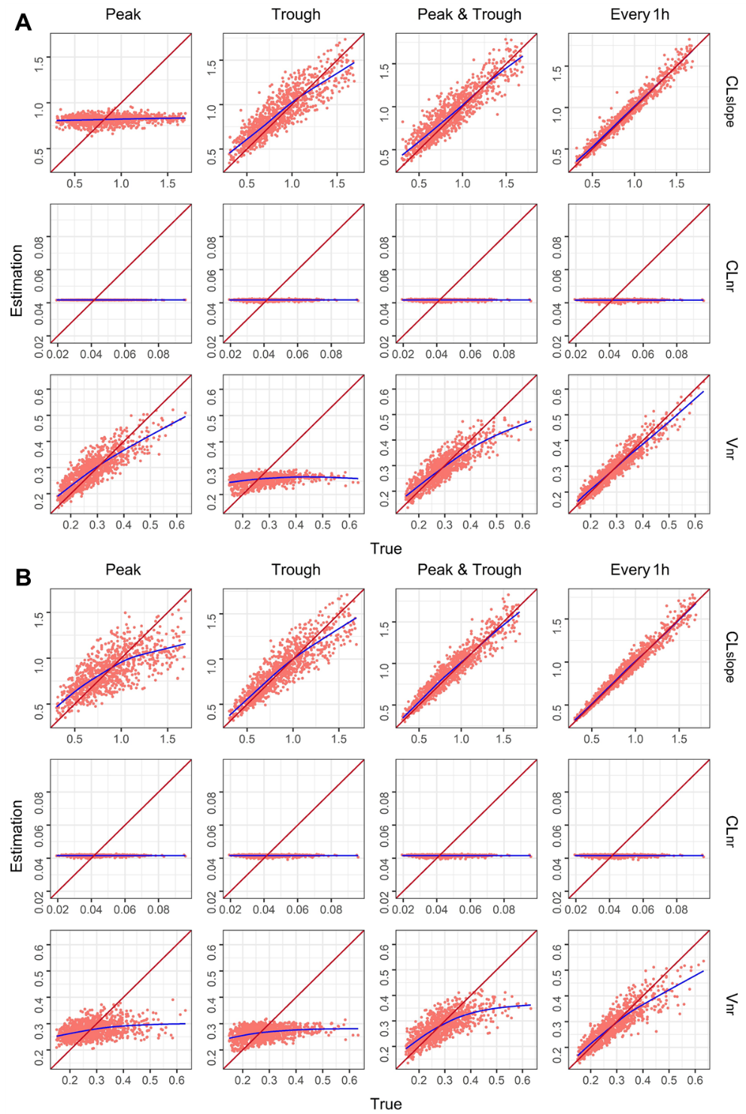

**Figure** **S9**. Graphs representing the amikacin parameters estimated versus true values in each internal validation scenario using MAP estimation. The identity line is shown in red and a trend line in blue has been drawn for each model. (**A**) Signal dose. (**B**) Steady state. **Abbreviations**: CLslope, rate of change in drug clearance with respect to creatinine clearance; CLnr, clearance independent of renal function; Vnr, distribution volume independent of renal function.

**Table S10.** Internal validation data estimation performance of vancomycin pharmacokinetic parameters using MAP estimation

|  |  |  |  |  |  |  |  |  |  |  |  |  |
| --- | --- | --- | --- | --- | --- | --- | --- | --- | --- | --- | --- | --- |
| **Sampling time** |  | **Peak** | |  | **Trough** | |  | **Peak and trough** | |  | **Every 1h** | |
|  | **MPE** | **RMSE** |  | **MPE** | **RMSE** |  | **MPE** | **RMSE** |  | **MPE** | **RMSE** |
| **Single dose** |  |  |  |  |  |  |  |  |  |  |  |  |
| CLslope |  | 4.12 | 0.25 |  | 8.61 | 0.17 |  | 7.67 | 0.16 |  | 5.33 | 0.13 |
| CLnr (mL/min/kg) |  | 1.08 | 0.01 |  | 1.12 | 0.01 |  | 1.11 | 0.01 |  | 1.06 | 0.01 |
| Vnr (L/kg) |  | 1.42 | 0.04 |  | 1.08 | 0.04 |  | -0.10 | 0.04 |  | -0.15 | 0.03 |
| k12 (1/h) |  | 6.96 | 0.20 |  | 5.38 | 0.22 |  | 5.12 | 0.19 |  | 4.73 | 0.19 |
| k21 (1/h) |  | 1.69 | 0.12 |  | 2.48 | 0.12 |  | 2.63 | 0.11 |  | 2.11 | 0.09 |
| **Steady-state** |  |  |  |  |  |  |  |  |  |  |  |  |
| CLslope |  | 1.85 | 0.15 |  | 3.67 | 0.11 |  | 2.49 | 0.08 |  | 1.21 | 0.04 |
| CLnr (mL/min/kg) |  | 1.00 | 0.01 |  | 1.02 | 0.01 |  | 0.99 | 0.01 |  | 0.96 | 0.01 |
| Vnr (L/kg) |  | 1.70 | 0.04 |  | 0.46 | 0.04 |  | -0.38 | 0.04 |  | -0.41 | 0.03 |
| k12 (1/h) |  | 6.41 | 0.22 |  | 4.55 | 0.22 |  | 4.07 | 0.20 |  | 4.26 | 0.20 |
| k21 (1/h) |  | 2.52 | 0.12 |  | 3.88 | 0.12 |  | 3.83 | 0.12 |  | 3.32 | 0.10 |

**Abbreviations** CLslope, rate of change in drug clearance with respect to creatinine clearance; CLnr, clearance independent of renal function; Vnr, distribution volume independent of renal function; k12, first-order transfer rate constant from the central compartment to peripheral compartment; k21, first-order transfer rate constant from the peripheral compartment to central compartment.

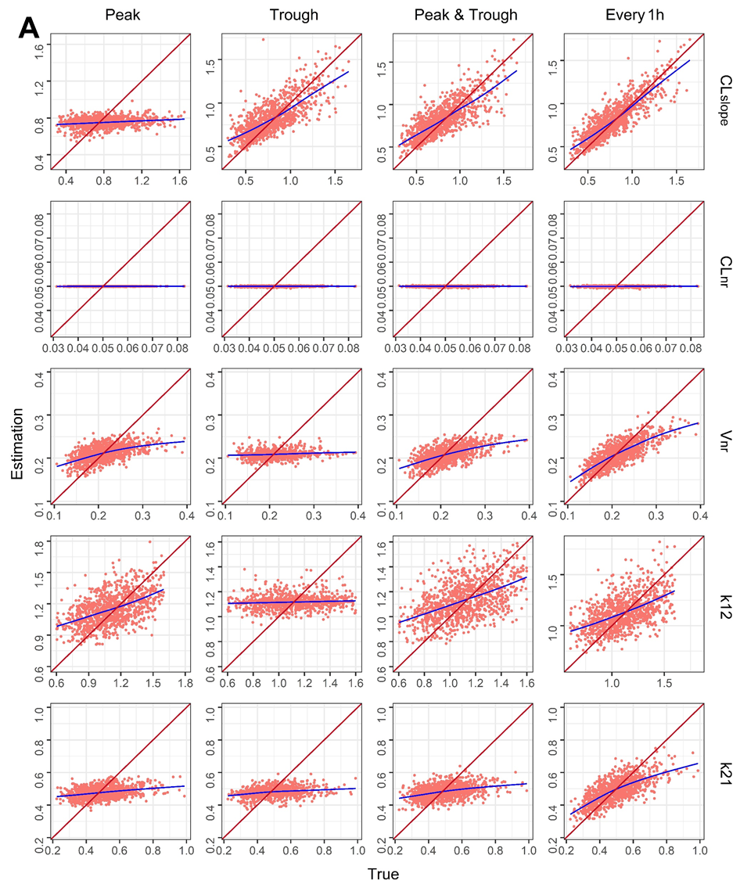

**Figure** **S2**. *Cont*.

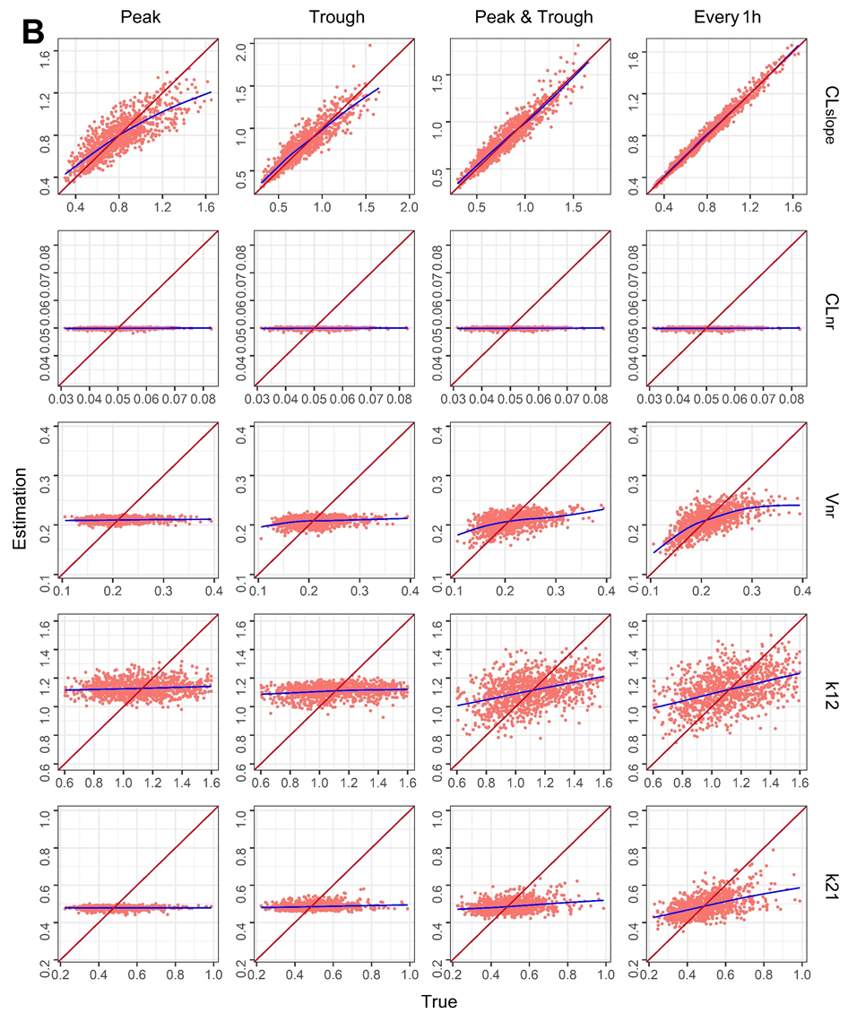

**Figure S10.** Graphs representing the vancomycin parameters estimated versus true values in each internal validation scenario using MAP estimation. The identity line is shown in red and a trend line in blue has been drawn for each model. (**A**) Signal dose. (**B**) Steady state. **Abbreviations** CLslope, rate of change in drug clearance with respect to creatinine clearance; CLnr, clearance independent of renal function; Vnr, distribution volume independent of renal function; k12, first-order transfer rate constant from the central compartment to peripheral compartment; k21, first-order transfer rate constant from the peripheral compartment to central compartment.

**Table S11.** Internal validation data estimation performance of theophylline pharmacokinetic parameters using MAP estimation

|  |  |  |  |  |  |  |  |  |  |  |  |  |
| --- | --- | --- | --- | --- | --- | --- | --- | --- | --- | --- | --- | --- |
| **Sampling time** |  | **Peak** | |  | **Trough** | |  | **Peak and trough** | |  | **Every 1h** | |
|  | **MPE** | **RMSE** |  | **MPE** | **RMSE** |  | **MPE** | **RMSE** |  | **MPE** | **RMSE** |
| **Single dose** |  |  |  |  |  |  |  |  |  |  |  |  |
| CLnr (mL/h/kg) |  | 1.44 | 5.83 |  | 1.78 | 5.24 |  | 1.47 | 5.30 |  | 1.56 | 4.62 |
| Vnr (L/kg) |  | 2.89 | 0.06 |  | 2.94 | 0.07 |  | 2.58 | 0.06 |  | 1.85 | 0.04 |
| **Steady-state** |  |  |  |  |  |  |  |  |  |  |  |  |
| CLnr (mL/h/kg) |  | 1.25 | 4.54 |  | 1.79 | 4.21 |  | 1.76 | 3.56 |  | 0.95 | 1.82 |
| Vnr (L/kg) |  | 2.67 | 0.07 |  | 1.81 | 0.07 |  | 1.80 | 0.07 |  | 1.49 | 0.07 |

**Abbreviations:** CLnr, clearance independent of renal function; Vnr, distribution volume independent of renal function.

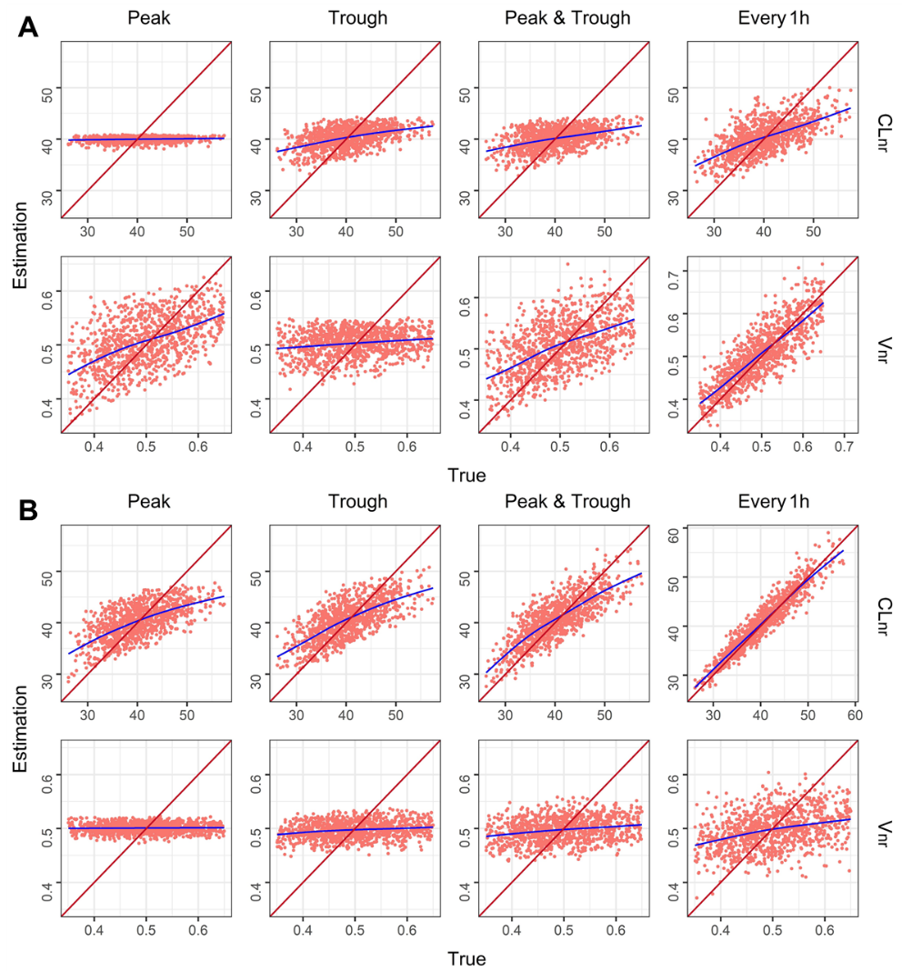

**Figure S11.** Graphs representing the theophylline parameters estimated versus true values in each internal validation scenario using MAP estimation. The identity line is shown in red and a trend line in blue has been drawn for each model. (**A**) Signal dose. (**B**) Steady state. **Abbreviations:** CLnr, clearance independent of renal function; Vnr, distribution volume independent of renal function.

**Table S12.** Internal validation data estimation performance of phenytoin pharmacokinetic parameters using MAP estimation

|  |  |  |  |  |  |  |  |  |  |  |  |  |
| --- | --- | --- | --- | --- | --- | --- | --- | --- | --- | --- | --- | --- |
| **Sampling time** |  | **Peak** | |  | **Trough** | |  | **Peak and trough** | |  | **Every 1h** | |
|  | **MPE** | **RMSE** |  | **MPE** | **RMSE** |  | **MPE** | **RMSE** |  | **MPE** | **RMSE** |
| **Single** **dose** |  |  |  |  |  |  |  |  |  |  |  |  |
| Vmax (mg/kg/d) |  | 3.15 | 135.41 |  | 3.45 | 134.71 |  | 3.54 | 135.05 |  | 3.86 | 130.56 |
| km (mcg/mL) |  | 10.57 | 2.04 |  | 9.69 | 2.01 |  | 9.62 | 2.03 |  | 8.30 | 1.98 |
| Vnr (L/kg) |  | 0.81 | 0.14 |  | 1.33 | 0.14 |  | 0.86 | 0.14 |  | 0.37 | 0.13 |
| **Steady**-**state** |  |  |  |  |  |  |  |  |  |  |  |  |
| Vmax (mg/kg/d) |  | -1.48 | 88.81 |  | -1.42 | 88.18 |  | -1.36 | 86.69 |  | -1.53 | 82.04 |
| km (mcg/mL) |  | 5.51 | 1.86 |  | 5.12 | 1.84 |  | 4.64 | 1.81 |  | 4.47 | 1.80 |
| Vnr (L/kg) |  | 2.05 | 0.15 |  | 1.39 | 0.15 |  | 1.62 | 0.15 |  | 1.71 | 0.14 |

**Abbreviations:** Vmax, maximum velocity; km, Michaelis constant; Vnr, distribution volume independent of renal function.

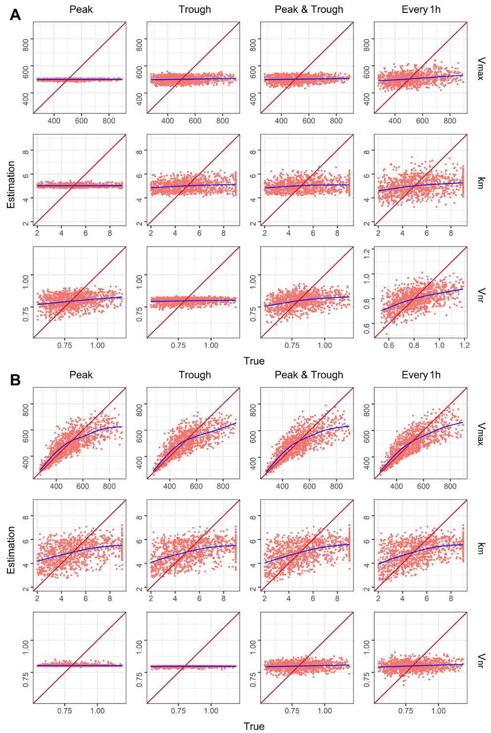

**Figure S12.** Graphs representing the phenytoin parameters estimated versus true values in each internal validation scenario using MAP estimation. The identity line is shown in red and a trend line in blue has been drawn for each model. (**A**) Signal dose. (**B**) Steady state. **Abbreviations:** Vmax, maximum velocity; km, Michaelis constant; Vnr, distribution volume independent of renal function.